#### CEP Presentation Template

The CEP Presentation Template provides a structured format for delivering a comprehen- sive and organized presentation of a CEP project. The template includes sections such as introduction, literature review, proposed solution, results, teamwork/task division, timeline, learning, and conclusion. It guides students in presenting their CEP projects by providing clear headings and subheadings for each section, ensuring a logical flow of information. The template emphasizes the importance of addressing societal and environmental impacts, aligning with Sustainable Development Goals (SDGs), and showcasing effective teamwork and time management. Overall, the CEP Presentation Template helps students effectively communicate their project’s objectives, methodology, findings, and overall learning experi- ence to the audience.

NOTE: List of SDGs given at the end for reference. They should not be present in the report.



CEP Presentation Title

Students Names and Registration Numbers



Outline

 Introduction

 Literature Review

 Proposed Solution

 Results

 Teamwork / Tasks Division

 Timeline

 Learning

 Conclusion



Introduction

 Brief introduction to the CEP

 Motivation and applications

 Aims and objectives



Literature Review

 Different options considered to solve the CEP



Proposed Solution/Methodology

 Mathematical model

 System design / block diagram

 Software / hardware model

 Circuit diagram / components / simulation diagram

 Flow chart / pseudocode / algorithm



Proposed Solution/Methodology

 Impact of proposed solution.

 Societal Impact*

 The students should discuss, what can be the potential advantages/ disadvantages of this project to any section of the society.

 Environmental Impact**

 The students should discuss, is the project environmentally sustainable, or what can be done to make it environmentally sustainable e.g. what material, equipment, practices etc. should be followed.

Goals (SDGs).

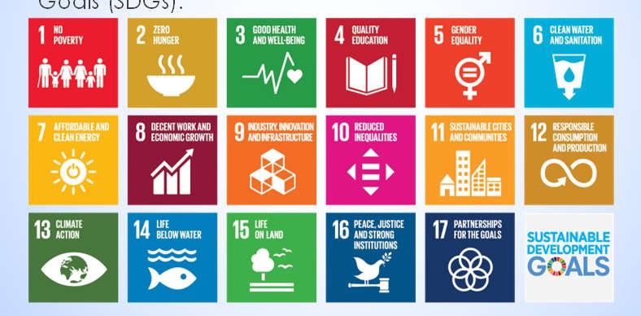

Proposed Solution/Methodology

 CEP addresses and focuses on these specific Sustainable Development



Results

 Data used and experimental setup for design/simulation

 Hardware/software simulation results

 Theoretical / analytical results

 Discussion



Teamwork/Tasks Division

 The students should explicitly communicate how they distributed among them the workload of the CEP

 The students effectively completed and presented the CEP as a team



Timeline

 Time management of the project, the Gantt chart should be based on the progress update reports/emails sent by the team to the teacher

CEP Timeline

Proposal Progress 1

Progress 2

Progress 3 Presentation/Report

0

2

Week

4

6

8



Learning from this project

 What are the new things students learned in this project that will help them in the longer run

 Standards/Protocols

 Problem solving tactics/strategies



Conclusion

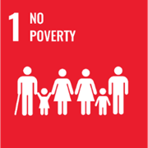End poverty in all its forms everywhere

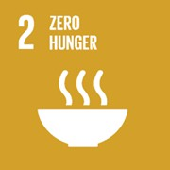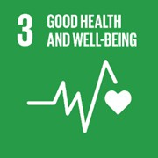End hunger, achieve food security and improved nutrition, and promote sustainable agriculture

Ensure healthy lives and promote well-being for all at all ages

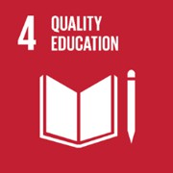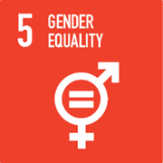Ensure inclusive and equitable quality education and promote lifelong learning opportunities for all

Achieve gender equality and empower all women and girls

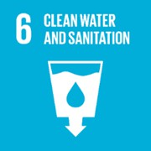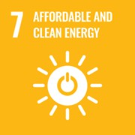Ensure availability and sustainable management of water and sanitation for all

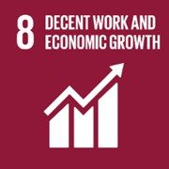Ensure access to affordable, reliable, sustainable, and modern energy for all

Promote sustained, inclusive, and sustainable economic growth, full and productive employment, and decent work for all

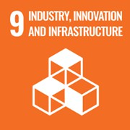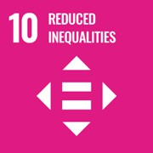Build resilient infrastructure, promote inclusive and sustainable industrial- ization, and foster innovation

Reduce income inequality within and among countries

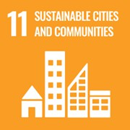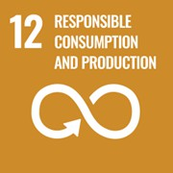Make cities and human settlements inclusive, safe, resilient, and sustain- able

Ensure sustainable consumption and production patterns

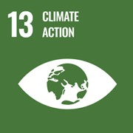Take urgent action to combat climate change and its impacts by regulating emissions and promoting developments in renewable energy

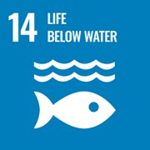Conserve and sustainably use the oceans, seas, and marine resources for sustainable development

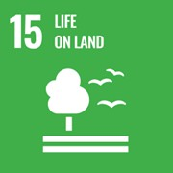Protect, restore, and promote sustainable use of terrestrial ecosystems, sustainably manage forests, combat desertification, halt and reverse land degradation and halt biodiversity loss.

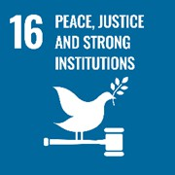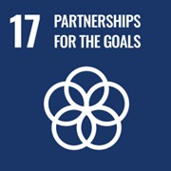Protect, restore, and promote sustainable use of terrestrial ecosystems, sustainably manage forests, combat desertification, halt and reverse land degradation and halt biodiversity loss.

Strengthen the means of implementation and revitalize the global partner- ship for sustainable development.